Use Case Document
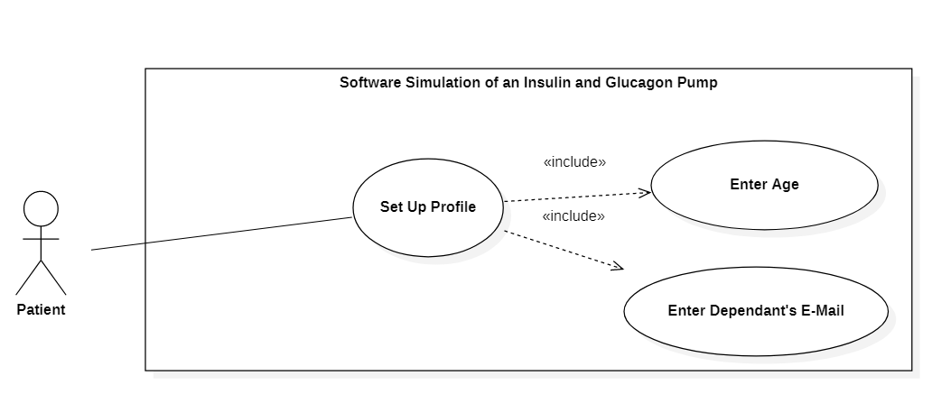

ID: | Set_Up_Profile_Usecase
Title: | Set Up Profile
Description: | This is the initial and One Time Activity where Patient registers himself/herself in the System. While setting up the profile, he/she must enter Age and Dependent’s details along with other fields.
Primary Actor: | Patient is the only and primary actor of this use case.
Preconditions: | This is the initial step for using the System. The only Pre-Condition is that the user should be a Diabetic Patient.
Postconditions: | The System can now be utilized by the Patient to view and track the Blood Sugar Level.
Main  Success Scenario: | Patient enters valid details to register himself/herself successfully into the system.
Extensions: | If Patient doesn’t enter a particular mandatory field or enters wrong details, he/she could not register by which he/she cannot use it further.
Frequency of Use: | This is an initial and One Time Activity. Most probably, the frequency of Use is 1. But If a User changes/updates his/her details, the frequency increases.
Status: | This use case is in Design Phase.
Owner: | All 4 members are working on it. So, everyone owns this use case.
Priority: | Medium

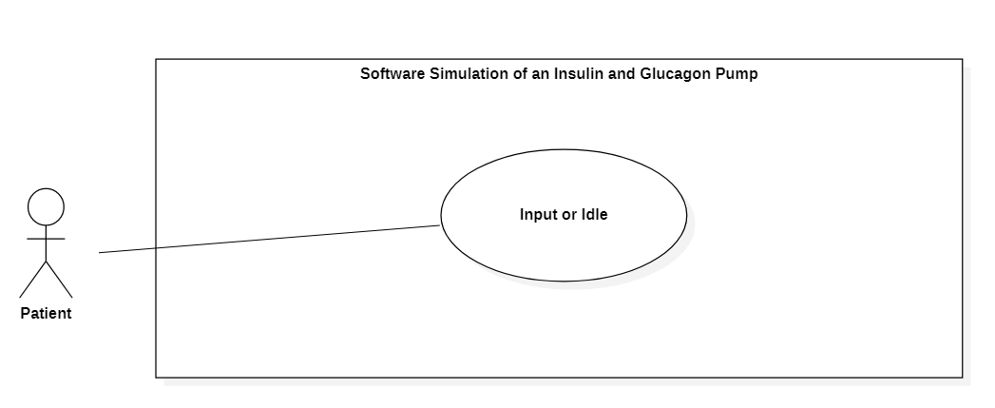

ID: | Input_Usecase
Title: | Input or Idle
Description: | Once the Patient registers, he/she is continuously being monitored for either whatever he/she eats or drinks, do exercises or doesn’t do anything at all. This use case is responsible for monitoring the Input taken by the Patient.
Primary Actor: | Patient is the only and primary actor of this use case.
Preconditions: | The only Pre-Condition is that the patient has successfully registered into the System.
Postconditions: | The Patient’s activity is properly recorded.
Main  Success Scenario: | According to the Patient’s Profile, all the records (Blood Sugar Level) captured/measured should be accurate.
Extensions: | A Patient’s Blood Sugar Level can be incorrectly measured or not measured at all due to technical issues in the System.
Frequency of Use: | There is a high frequency of this use case as the patient is being continuously monitored for any kind of inputs taken.
Status: | This use case is in Design Phase.
Owner: | All 4 members are working on it. So, everyone owns this use case.
Priority: | High

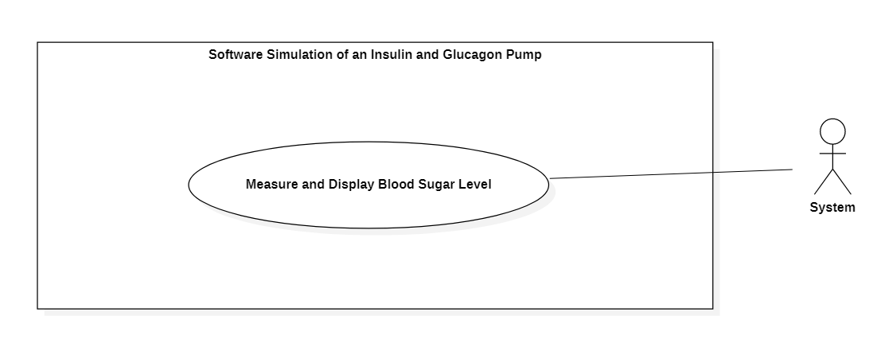
ID: | Measure_Sugar_Level_Usecase
Title: | Measure and Display Blood Sugar Level
Description: | Once the Patient takes any input (Food, Drinks etc.), the System measures and displays the updated Blood Sugar Level.
Primary Actor: | System is the primary actor of this use case.
Preconditions: | The only Pre-Condition is that the patient should have taken or not taken any input.
Postconditions: | The System has calculated and displayed the updated Blood Sugar Level after Patient has something/nothing in the body.
Main  Success Scenario: | The System has correctly measured the Blood Sugar Level.
Extensions: | The System may calculate incorrect results due to technical issues in the System.
Frequency of Use: | There is a high frequency of this use case as the System continuously measures and displays the Blood Sugar Level.
Status: | This use case is in Design Phase.
Owner: | All 4 members are working on it. So, everyone owns this use case.
Priority: | High

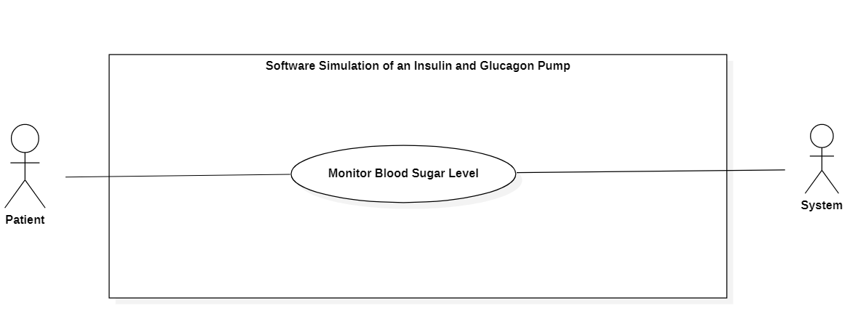
ID: | Monitor_Sugar_Level_Usecase
Title: | Monitor Blood Sugar Level
Description: | The System continuously monitors the Blood Sugar Level of the patient to check that the level doesn’t exceed the Hyperglycemia or Hypoglycemia and displays the results to Patient, so that the Patient can continuously monitor and keep track of his/her Blood Sugar Level.
Primary Actor: | System is the primary actor of this use case. And Patient is the secondary actor of this use case.
Preconditions: | The System should be in a proper state to give accurate results.
Postconditions: | The System is monitoring correct results.
Main  Success Scenario: | The System is monitoring the Blood Sugar Level accurately.
Extensions: | The System may not encounter any of the limit exceeded due to technical issues in the System.
Frequency of Use: | There is a high frequency of this use case as the System and the Patient continuously monitors the Blood Sugar Level.
Status: | This use case is in Design Phase.
Owner: | All 4 members are working on it. So, everyone owns this use case.
Priority: | High

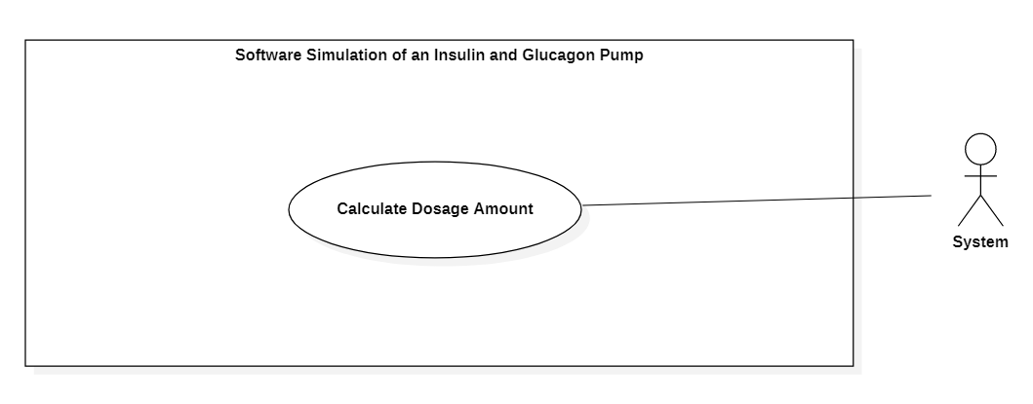
ID: | Calculate_Dosage_Usecase
Title: | Calculate Dosage Amount
Description: | The System calculates the amount of Insulin/Glucagon dosage to be injected to Patient in case of BSL exceeding Hyperglycemia or Hypoglycemia resp.
Primary Actor: | System is the primary actor of this use case.
Preconditions: | The Patient exceeds Hyperglycemia or Hypoglycemia level.
Postconditions: | The system has the amount of dosage to be injected.
Main  Success Scenario: | The System measured the correct Insulin/Glucagon Dosage amount to be injected.
Extensions: | The System may calculate wrong results due to technical issues in the System.
Frequency of Use: | There is a medium frequency of this use case as the Patient does not exceed the Hyperglycemia or Hypoglycemia levels frequently.
Status: | This use case is in Design Phase.
Owner: | All 4 members are working on it. So, everyone owns this use case.
Priority: | Very High

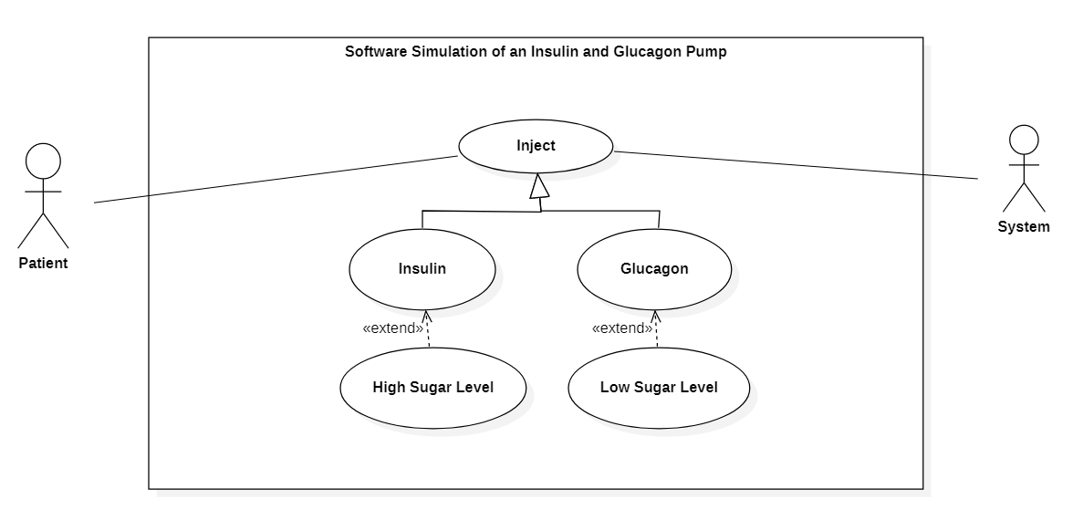
ID: | Inject_Usecase
Title: | Inject
Description: | When the Blood Sugar Level goes high or exceeds Hyperglycemia, the Insulin is injected to the Patient. When the Sugar Level goes low or exceeds Hypoglycemia, the Glucagon is injected to the Patient.
Primary Actor: | Patient is the primary actor of this use case.
Preconditions: | The type and proper amount of dosage to be injected is calculated.
Postconditions: | The Patient is injected the dosage so that his/her BSL becomes normal.
Main  Success Scenario: | The BSL of patient becomes normal.
Extensions: | The Patient may be injected with wrong dosage to make the situation even worse.
Frequency of Use: | There is a medium frequency of this use case as the Patient does not exceed the Hyperglycemia or Hypoglycemia levels frequently.
Status: | This use case is in Design Phase.
Owner: | All 4 members are working on it. So, everyone owns this use case.
Priority: | Very High

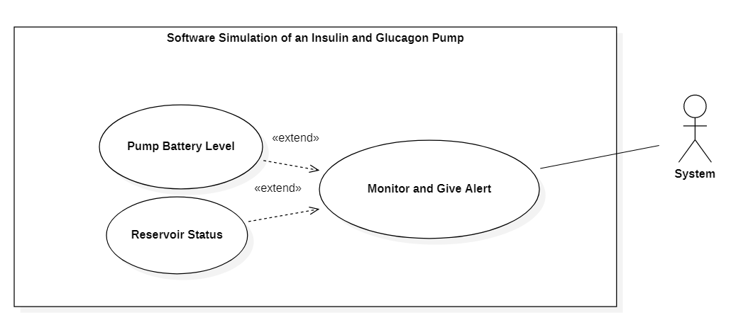
ID: | Alert_Usecase
Title: | Monitor and Give Alert
Description: | Whenever the Pump’s battery level is low or Reservoir’s are becoming empty, the Patient is alerted by the System. The System continuously monitors such kind of things for safety purposes.
Primary Actor: | System is the primary actor of this use case.
Preconditions: | The Pump’s Battery should be low or the Reservoir’s status is going to become empty.
Postconditions: | Patient takes an appropriate action to solve the issues.
Main  Success Scenario: | Patient is effectively alerted about such Safety Critical issues.
Extensions: | The System may be unable to alert the Patient.
Frequency of Use: | There is a medium frequency of this use case as these events occur after a specific period.
Status: | This use case is in Design Phase.
Owner: | All 4 members are working on it. So, everyone owns this use case.
Priority: | Very High

